Unit 4: Who’s your best friend?

Speaking: Describing people

Grammar: Relative clauses

Reading: Types of friendships

Warm-up
- Describe your best friend

As we get older, relationships change. We lose contact with some friends. Our interests change. It might be helpful to think about the person closest to you now… but also reflect on past relationships also.

Vocabulary
- Characteristics (describing people)
  - What three vocabulary terms best describe YOU and why?
  - This is a common job interview question.
  - Can you think of other characteristics that describe you?

Grammar
- Explanation: Relative clauses
  - https://www.ef.com/wwen/english-resources/english-grammar/relative-clauses/
- Extra Practice: https://www.perfect-english-grammar.com/relative-clauses-exercise-1.html

- Video: https://www.youtube.com/watch?v=a_mFlafGyy8

Reading

- “Circles” and relationships
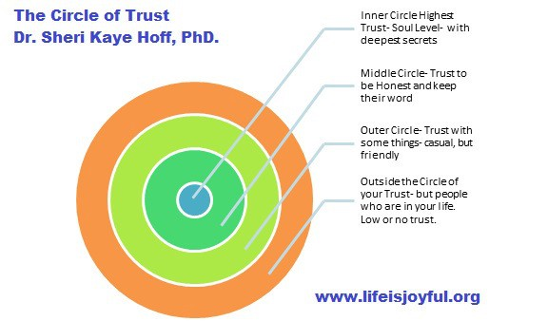

Conversation Questions
Practical Vocabulary:
Type A personality
someone who is ambitious, goal-driven, focused on achievement, competitive, organized, proactive, and in control
Type B personality
Relaxed, easy-going, not so organized, doesn't mind being a 'follower', focused on enjoying themselves, balance is more important than risk

Which personality type is YOU?
- https://www.buzzfeed.com/genamourbarrett/are-you-more-type-a-type-b-or-type-c

- Do you think it is a good idea to borrow money from a friend? Why or why not?
- Do you make friends easily?
- Has a friend ever let you down?
- How are your friendships different now than they were when you were a child?
- How do you maintain a good friendship?
- How do you make new friends?
- How many people do you consider your "best friends?"
- Is it common to have friendships across generations? (Age)
- What do you usually do with your friends?
- What factors may result in the breakdown of a good friendship?

Just for fun: Online personality quiz
- https://www.buzzfeed.com/spenceralthouse/accurate-personality-test

